CHUBB Global Market[CGM]
Test Approach

Version : 1.4
Date : 19 Mar 2016
Produced By : CGM SIT Team
CHUBB Global Market [CGM] Test Approach: Signoff

This document requires the following approvals.

Name | Role | Approval Status | Date

Distribution List:

Name | Summary | Review Date
Neil Collis | AVP, Strategic Programmes
Graeme Williamson | IT Project Manager | 8th Mar 2016
John Rowland | IT Business Architect
Reena Paul | CGM PM | 9th Mar 2016
Chetan Goyal | CTS Technical Lead | 9th Mar 2016
Jim Nord | Vega Design Lead
Aravind Ravichandar | Test Lead

Change Control Log - Revision History:

Date | Summary | Version | Author
30th Jan 2016 | Work View CGM Test Approach | 1.0 | Ratesh Loganathan
22nd Feb 2016 | Work View CGM Test Approach | 1.1 | Ratesh Loganathan
29th Feb 2016 | Work View CGM Test Approach | 1.2 | Ratesh Loganathan
11th Mar 2016 | Work View CGM Test Approach | 1.3 | Ratesh Loganathan
19th Mar 2016 | Work View CGM Test Approach | 1.4 | Ratesh Loganathan

Table of Contents

1 Introduction 6
1.1 Purpose 6
1.2 Project Background 6
2 Test Objectives 8
3 Test Scope 9
3.1 In Scope 9
3.2 Out of Scope 12
4 Test Approach 13
4.1 Test Initiation / Approach Definition 14
4.2 Requirement Analysis / Test Planning 14
4.3 Test Design 15
4.4 Test Execution 15
4.5 Test Closure 15
5 Test Components / Functionalities 16
5.1 Work View CGM: 16
5.2 Work View CGM: Core / Extended Design 16
5.3 Overall Estimated Test Cases Count: 16
6 Leveraging From ASPAC & NA 18
6.1 Test Design 18
6.2 Test Execution 18
7 Test Methodology 19
7.1 Smoke Testing 19
7.2 System Integration Testing 19
7.3 End to End Testing 33
8 Test Plan 35
9 Quality Gates 36
10 Test Tools 37
11 Defect Management 38
11.1 Defect Life Cycle 38
11.2 Defect Triage 40
11.3 Defect Classifications 40
11.4 Defect Business Severity 40
11.5 Defect Fix Priority 41
12 Test Data 42
13 Test Metrics 43
14 Test Environments 44
15 Test Deliverables 45
16 Test Criteria 47
16.1 Test Entry / Exit Criteria 47
16.2 Test Suspension / Resumption 49
16.3 Test Assumptions / Dependencies 49
16.4 Risks / Contingencies: 51
17 Roles & Responsibilities 52
18 RACI Matrix 54
19 Reference Documents 56

Introduction

Purpose

The purpose of this document is to define the overall test approach for the CHUBB Global Market Release 1 of CHUBB Insurance. The test approach defines the scope of the test stage enabling a common understanding of the areas that will be tested, and the processes that will be followed for test preparation and execution, test management, types of testing, test environments used, change & defect management and entry & exit criteria for each phase.

The purpose of test approach is to:
- Define how the appropriate testing principles and practices will be applied in order to manage testing risks and identify issues in quality
- Define scope of testing to enable development of test conditions, test cases and test plans to be produced
- Provide a common platform to be followed for testing across multiple organizational structures and business units
- Provide a direction for the testing activities to be carried out with the workflows
- Serve as a communication vehicle to identify any testing issue early in the project lifecycle

It also acts as a document of understanding regarding testing between the testing team, project management team and stakeholders of the project.

Project Background

CGM Workflow Application is used for Administration of CHUBB Global Market. CGM Workflow system utilizes a version of Pega which is now unsupported and Enhancement and Maintenance is uneconomical. Classic Apollo is used as Document Repository for CGM Master Policies and its subsequent transactions

The Work View Program has been commissioned to replace CHUBB Apollo’s current ageing architecture with an CHUBB strategic Enterprise Case Management (ECM) solution. This will be delivered based on an IBM FileNet solution with a user Interface developed by Vega. This is intended to provide existing functionality with opportunities for process consistency and an enabler for operational and technology efficiency.

Work View CGM Program - Application Landscape

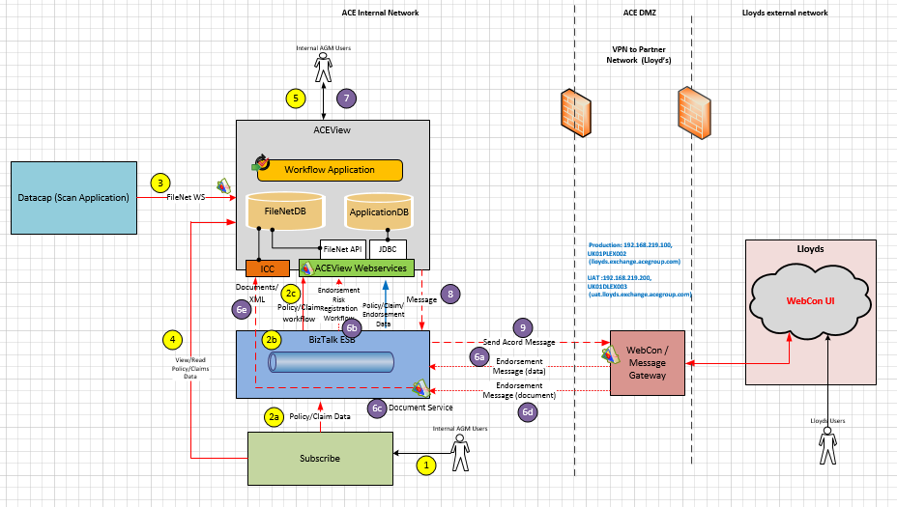

Test Objectives

The key objectives of testing are:

- Verify that the solution meets the business requirements so that the system can be used effectively in the target environment. The application's support of business needs is addressed by formally testing the functionality, operations, procedures and performance of the application.

- Ensure operational reliability by uncovering defects in the system early on and fixing them. This includes locating logic errors and other defects that may cause the system to be unreliable.

CGM Testing is to ensure that the constituent components of the system will operate and communicate with each other as designed; ensuring that both the functional and non-functional behaviors are working as expected and the end to end systems are stable. Testing will include both ‘end to end’ testing of data flows across the components, and Interface testing, which will prove communications between systems are still working effectively. It will ultimately demonstrate that any newly added functionality is working, and that pre-existing functionality is still working.

The above Testing objectives are achieved through -

Test Objective | Achieved by
Verify the quality of code is good enough to test in SIT environment | Sanity / Smoke Testing
Verify the functionalities of individual components with respect to business requirements | System Testing
Verify the functionalities and the communication between integrated systems | System Integration Testing
Verify the end to end system business workflow is fit for business purpose | End to End Testing
Verify that existing business processes have not been negatively impacted after each build | Regression Testing

Test Scope

In Scope

The test in-scope components are divided into four groups:

- CGM Underwriting Updates: Policy and Policy Subsequent Transaction integration to Work View from Subscribe System.
- CGM Workflow: CGM specific workflows upon different underwriting process.
- Core: Reuse the Core Work view NA Functionalities for Document and workflow management.
- Core Extended: Update the test cases based on the region wise business rules / file properties.

CGM Workflow - High Level Overview:

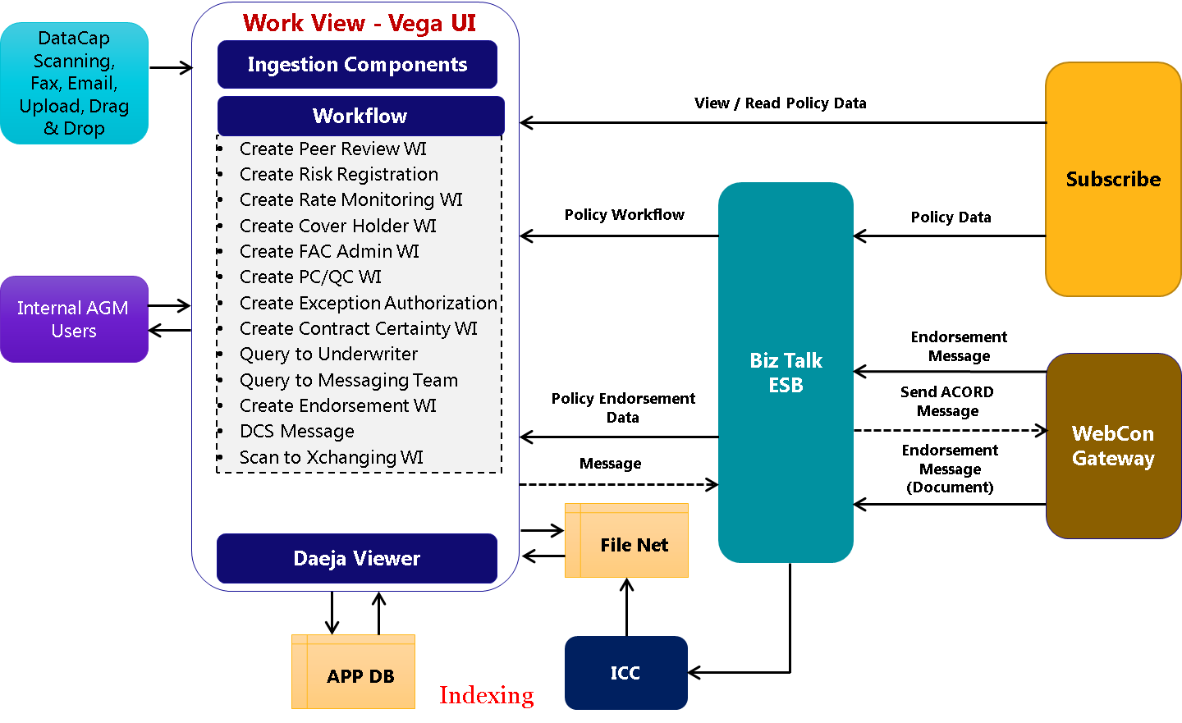

CGM Workflow:

- Create Peer Review WI
- Create Risk Registration
- Create Rate Monitoring WI
- Create Cover Holder WI
- Create FAC Admin WI
- Create PC/QC WI
- Create Exception Authorization
- Create Contract Certainty WI
- Query to Underwriter
- Query to Messaging Team
- Create Endorsement WI
- DCS Message
- Scan to Xchanging WI

Interfaces:

- Subscribe
    - Create Policy/Claim File
    - Open/View File
    - Update File
- WebCon
    - Message Validation

Core Components:

  - Ingestion
    - Drag & Drop
    - Email Broker
    - Datacap Scanning
    - Upload
    - Save and Send
    - Send Fax
    - Send Email

  - XPression
a. Barcode Generation
b. Document Generation

  - Daeja Viewer
    - Viewer Configuration
    - Bookmark
    - Split/Merge

Core Extended Components:

- Security
    - PIP/PAP/PDP
    - Single Sign On
    - System Access
    - User Preferences

- VEGA UI
    - View Notification
    - Diary
    - Flags & Milestones
    - Alerts & Notes
    - Search Templates
    - Document Panel
    - Perform Document Indexing
    - Work Basket Actions
    - Work Basket Redirect
    - Work Basket Filters
    - Open Files/Work Items
    - Workflow (Indexing Work Item, Document Indexing)

Performance Testing, Data and Document migration document are in scope for SIT and covered in a separate approach document.

Out of Scope

The following types of testing will be out of scope for SIT:

      - Unit Testing
      - Application Testing - Subscribe, WebCon
      - Multi-Lingual Testing
      - User Acceptance Testing
      - Disaster Recovery Testing
      - Performance Testing
      - Data Migration will be covered in a separate Test Stratergy

Test Approach

This section describes the testing approach that would list the various test phases, techniques and tools used for the same. The tools and processes used for the test phases would also be listed as part of the approach.

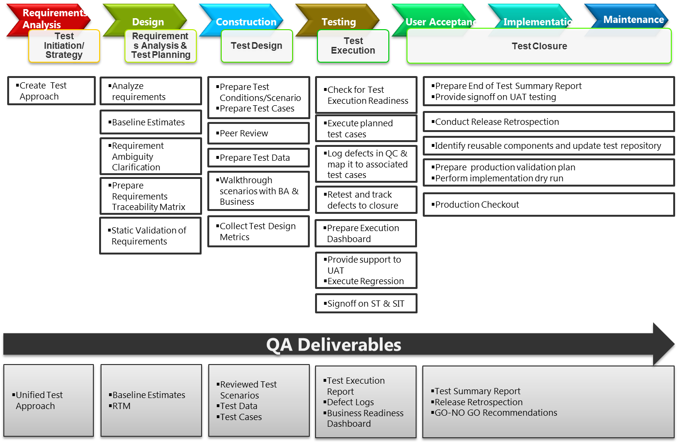

The Testing of Work View CGM application will contain the following 5 phased approach for testing:

- Test Initiation / Approach Definition
- Requirement Analysis / Test Planning
- Test Design
- Test Execution
- Test Closure

Test Initiation / Approach Definition

The testing team would outline the high-level overview of the entire testing timeline based on the development build plans for SIT drops. The testing team will also define the test approach to describe the plan for testing activities, test scope, test process, test deliverables, test completion criteria, test prioritization, tools support, resourcing, and responsibility matrix.

Requirement Analysis / Test Planning

4.1.1 Requirement Analysis

The testing team would work with the Requirements team and Business analysts to understand the overall system architecture and testing requirements. The team will understand the components, services offered by the components, wireframes, use cases, application architecture and other relevant system information. The project documents available in CHUBB SharePoint (Business requirements, functional specifications, Use Case documents, configuration documents, etc.) will be used for the study, to accurately understand and analyze the requirements for testing. The testing team will also work on collating the testing artifacts such as requirement ambiguities tracker, requirement clarifications tracker and requirement traceability matrix. These interactions and artifacts will form the base from which the testable requirements will be harvested so as to formulate a test plan.

4.1.2 Test Planning

The testing team will work with test coordinators to develop a test plan that will be applicable across different types of testing that would be conducted under Work View project. Key activities such as effort estimation and resource loading required for the Work View CGM project are performed. The testing approach and scope for each type of testing is determined. All potential risks and mitigation plans are identified during the test planning phase.

Test Design

This phase will dwell on identification of test scenarios, construction of test cases and test data. For each functional requirement, the testing team will identify one or more test scenarios, and for each scenario, one or more test cases, and for each test case, corresponding test data is created. The test cases would also be mapped to the requirements for traceability. The test design artefacts will be reviewed with BA / PM for business confirmation and sign-off.

Test Execution

Once the test cases and test data are signed off, and the test environment is set up, the test cases would be executed in this phase. During this phase, the testing team will execute the test cases, document the test results, report and track defects to logical closure. Test Execution is carried out in two phases - Cycle 1 and Cycle 2. In Cycle 1, all test cases (100%) would be executed and the testing in Cycle 2 with 40% of test cases being executed with an assumption of 30% failure rate in Cycle 1. System and System Integration test execution would utilize the Web Interface for testing. Fixes should only be deployed into the test environment with agreement from the Test Management Team

Test Closure
At the end of a test execution cycle, the testing team would submit test summary results report summarizing the test execution status, defect severity and test execution coverage. Upon completion of all the testing cycles, the testing team will submit a test closure report along with AQI (Application Quality Index) which will highlight the key metrics that can be used to determine the improvement opportunities and the quality of the application.

Test Components / Functionalities

Work View CGM:
http://europespace.CHUBBgroup.com/sites/AR_CGM_Project/SitePages/Home.aspx

Work View CGM: Core / Extended Design
http://europespace.CHUBBgroup.com/sites/AR_CGM_Project/Shared%20Documents/06_Technical_Design/Vega%20TDDs/Baseline%20Designs/ApolloRefresh_CGM_Extended_Design_v1_1.docx

Overall Estimated Test Cases Count:
Test Components | Test Cases Count
Work View CGM Workflow | 450
Work View CGM – Interfaces | 300
Work View CGM - Core / Extended Design | 2300
Total Test Case | 3050

The given test case count is based on the initial analysis done on the existing functional design documents, UI configuration documents.

Individual test scenarios/scripts will not be listed in this document but will be held within the test management tool HP ALM 11.0 with the below alignment to achieve maximum reusability.

URL : http://uk01dqct004:8080/qcbin/start_a.jsp
Domain : AOG_GDC_DEVELOPMENT
Project : Apollo_Refresh_Global
Test Plan Path : Subject\Work View_Release 1_CGM_SIT_QA Team

Folder Structure Alignment:

- Core: Reuse across the regions without any change.
- Core Extended: Update the test cases based on the region wise business rules / file properties.
- CGM: Regional functionalities related to CHUBB Global Market.

SharePoint Link for Test Artefacts

Test Approach Document
http://europespace.acegroup.com/sites/AR_AGM_Project/Shared%20Documents/Forms/AllItems.aspx?RootFolder=%2Fsites%2FAR%5FAGM%5FProject%2FShared%20Documents%2F05%5FTest%2F01%20Test%20Approach

Test Scenario Documents
http://europespace.acegroup.com/sites/AR_AGM_Project/Shared%20Documents/Forms/AllItems.aspx?RootFolder=%2Fsites%2FAR%5FAGM%5FProject%2FShared%20Documents%2F05%5FTest%2F02%20Test%20Scenarios

Test Case Documents
http://europespace.acegroup.com/sites/AR_AGM_Project/Shared%20Documents/Forms/AllItems.aspx?RootFolder=%2Fsites%2FAR%5FAGM%5FProject%2FShared%20Documents%2F05%5FTest%2F03%20Test%20Cases
Clarification Logs
http://europespace.acegroup.com/sites/AR_AGM_Project/Shared%20Documents/Forms/AllItems.aspx?RootFolder=%2Fsites%2FAR%5FAGM%5FProject%2FShared%20Documents%2F05%5FTest%2F04%20Clarification%20Logs

Leveraging From ASPAC & NA

Test Design

- Reusability of Test Cases from ASPAC & NA core components (Daeja Viewer, Ingestion, Send Email, Send Fax, Notes, Alerts, Notifications, etc.) to optimize the overall test design effort for CGM (Approx. 30% reusability of ASPAC & NA core components test artefacts).

- Leveraging ASPAC & NA Core Business Knowledge & Expertise by involving the ASPAC & NA QA resources during CGM test design.

Test Execution

- Reusing the complete Test Data Setup prepared for ASPAC & NA components (Daeja Viewer, ICC, Upload, Drag & Drop, Send Fax, Send Email, etc.) during CGM test execution.

- Adapting the best practices & automated utilities developed in ASPAC - Automated Daily Quality Dashboard, Automated ICC Audit Log Verifier, Dynamic Screen Capture Tool, Automated QC Utilities, etc.

Test Methodology

Smoke Testing

Objective:

Smoke testing is aimed at validating whether the application is stable enough to qualify for any formal testing by the testing team.

Approach/Activity:

This testing involves the execution of a set of core functionalities of the Work View CGM project to ensure there is no show stopping defect along the critical path. For a new build, these test cases are executed to determine whether the build is stable enough to undergo a full round of testing. A failure during Smoke testing will result in suspension of testing. All scheduled builds will undergo a full round of smoke testing in SIT environments.

Deliverables:

- Smoke test cases
- Smoke test log

System Integration Testing

Objective:

System Integration Testing will be performed to evaluate the system's compliance with its specified functional requirement and the integration of the system with upstream and downstream components will be tested as part of this phase. The SIT phase aims to determine if Interface behavior and information sharing between the components are working as specified. The test team will ensure that all the components delivered to this test phase comply with the defined Interface definition, in terms of standards, format and data validation.

Approach/Activity:

System Interface Testing would be performed using the User Interface. Work View should be available with all components integrated with the internal/external Interfaces. The test cases are created for all functionalities in the application and then executed. Defects, if any, are reported using the Defects tab of HP ALM. The following are the key activities that will be performed as part of SIT.

- The SIT test scenarios are identified based on the functional specification
- Detailed test cases are prepared based on the reviewed and signed off test scenarios
- The required test data is prepared by the testing team and reviewed by CHUBB
- The test artifacts are placed in HP ALM and executed in Cycle-1 and Cycle-2 (Defect fixes and rerun) through UI Interface
- SIT Test Summary Report is delivered and signed off by Work View System Test Manager

Work View CGM: Interfacing Systems Testing

Systems | Test Approach | Activity | Owner | Dependencies
Subscribe | - Creation of Master and Line Policies/Claims in Subscribe System.  - Creation of Subsequent Policy Transaction such as Renewal, Endorsement, Cancellation , New Business | Data Creation / Prod. Data Feed | SIT Team | - The Subscribe system needs to be integrated with Work View Via BizTalk & available for data creation on or before 10th May 2016
Subscribe | - Scheduled Batch Process to Update / Create Policy/Claim Files into Work View in every 5 Mins.  - Web Service Connectivity to create the New Submissions in Work View System as and when it gets created in Subscribe System | Run Batch Job / Web Service | Work View Dev Team | - The necessary support from Development Team for running the batch process / maintaining the web service active to retrieve & update details from Subscribe to Work View.
Subscribe | - Validating the Policy/Claim and its subsequent transactions in Work View that are created in Subscribe System | Testing | SIT Team | - Access for Work View / Subscribe needs to be provided to SIT Team for validation purpose.
Subscribe | - Validation of document ingestion process  - Creation & Validation of CGM Business Workflows  - Validation of document indexing & linking to a policy/claim file | Testing | SIT Team | - Access for Work View system needs to be provided to SIT Team
WebCon Gateway | - E-Endorsement Message Set up in WebCon Message Gate Way  - Placing of Document slip which needs to be routed to Xchanging  - Validation of Acknowledgement notification in WebCon once after the successful creation Work Item in Work View  - Development team to provide Stub Utility so that SIT team will provide test data which will be processed and available for SIT testing | Testing | SIT Team | - WebCon Message Gateway should be integrated with Work View.  - WebCon gateway and its web service should be up and running.
WebCon Gateway | - Validation of Endorsement Work item created in Work View System once after receiving the Message from WebCon  - Indexing, Re-assign and Complete the Work item in Work View System | Testing | SIT Team | - WebCon gateway and its web service should be up and running.  - Test Data will be created in the XML feed File
Work View CGM: CGM Interface Data Feed Process
CGM Interfacing Functionality | Source System | Destination System | Communication Mode for  Data Flow
View Read Only data from Subscribe in Work View Screen | Subscribe | Work View | Real Time - On Demand
*Quote-Policy Reference Validation- In Progress | Subscribe | Work View | Near Real Time (2 mins)
*Search Policy Reference – In Progress | Subscribe | Work View | Real Time - On Demand
Rate Monitoring Process | Subscribe | Work View | Scheduled – Near Real time
Peer Review Event Handlers | Subscribe | Work View | Scheduled
Synchronize policy/claim, policy re-reference data | Subscribe | Work View | Scheduled
Receive ACORD Message e- Endorsement / Acknowledgements | WebCon | Work View | Scheduled - Near Real Time
Receive ACCORD Message - Placement message from DCS via WebCon gateway And Route it to the risk registration team within Work View as work item | WebCon | Work View | Scheduled - Near Real Time
Send ACORD Message - Request For Information/ Request For Negotiation etc. | Work View | WebCon | Real Time - On Demand
Send the scan image of the UW slip and send it to Xchanging via WebCon Gateway | Work View | WebCon | Real Time - On Demand
QC Validation Process | Subscribe | Work View | Scheduled
*Details to be updated after Sign-off of the Functional Specification
Work View CGM: CGM Test Data Requirement from Subscribe Team

All the Cycle1 Files to be available by 20th May 2016 & for Cycle2 by June 15th 2016

S.No | Transaction Type | Test Data Specification | *No. of Files (Cycle 1) | *No. of Files (Cycle 2) | Remarks
1 | All Transaction Type | Quote/Policy Files and Claim Files with Different transaction and Status | 250 | 130 | - Cycle-1: Required Policy Batch feed of Subscribe on 20th May 2016  - Cycle-2: Required Policy Batch feed of Subscribe on 15th Jun 2016.
2 | Submission Quote | Quote creation in Subscribe for multiple LOBs | 50 | 30 | - Subscribe team to provide the Files with requested data specification / required access to Subscribe System to perform the necessary transactions
2 | Submission Quote | Quote Submission with different Premium details [Rate Monitoring] | 50 | 30
3 | New Business | New Business Policy with Partial/Live Status [Peer Review] | 50 | 30
3 | New Business | Policy set with FAC Alert Flag as “YES” [FAC Admin] | 50 | 30
3 | New Business | - Creation of New Business Policy with Live Status [Cover Holder]  - Update the Policy Contact details [Cover Holder] | 50 | 30
4 | Renewal | Renewal Quote Creation in Subscribe where Premium should Exceed the UWR Authority Limit [Policy Processing WI] | 50 | 30
4 | Renewal | Creation of New Business Policy which is 120 days Due for renewal [Cover Holder Renewal Binder] | 50 | 30
4 | Renewal | Renewal Quote Submission with different premium details [Rate Monitoring] | 50 | 30
4 | Renewal | Renewal Policy with Partial/Live Status [Peer Review] | 50 | 30
5 | Endorsement | Endorsement Creation on New Business Policy [Rate Monitoring Work Item] | 50 | 30
5 | Endorsement | Endorsement Creation on Renewal Policy [Rate Monitoring Work Item] | 50 | 30
5 | Endorsement | Creation of Endorsement in which update the contact details [Cover Holder] | 50 | 30
5 | Endorsement | Policy Set with FAC Alert Flag as “YES” [FAC Admin] | 50 | 30

Work View CGM: Ingestion Components Testing

High Level Ingestion Process
Add files into Work View and move them between cases and files within the system using Drag & Drop, File Import, Apollo Print, Email Broker and then Index to the work queue.
Different operations/activities can be performed: | 1. Copy or move or link document from one file to another  2. Delete the linked documents
Process/Tools/Methods | Source/Input | Target | Coverage | Dependencies
Drag & Drop | Outlook - Emails (Single / Multiple), Attachments (Single / Multiple) | Policy/Claim files, Work Item | - Single/Multiple Files  - Different File Types & Formats (MSG, PDF, XLS, DOCX, etc.)  - Different File Sizes  - Different File Locations | - Drag & Drop ActiveX control need to be installed  - Production Samples of various documents should be needed
Drag & Drop | Local Files / Network Drive | Policy/Claim files, Work Item
Drag & Drop | Workspace - Document Tree > Tree View | Policy/Claim files, Work Item
File Import | Local Files / Network Drive | Policy/Claim files, Work Item | - Different File Types & Formats (MSG, PDF, XLS, DOCX, etc.)  - Different File Sizes  - Different File Locations | - Production Samples of various documents should be needed
Apollo Print | Local Files / Network Drive | Policy/Claim files, Work Item | - Different File Types & Formats | - Apollo Print Software need to be installed & configured in test systems
Email Broker | Outlook - Email | Policy/Claim files, Work Item | Test using the below combination,  - Different Mail Boxes  - Mails-To-Target Workbasket Mapping | - Access to ICC Server  - Microsoft Outlook need to be configured  - Email Boxes need to be configured in tester machines
Send Fax | Ingested Documents | - Target Fax Recipients  - Policy/Claim files, Work Item | - Different File Types & Formats (MSG, PDF, XLS, DOCX, etc.)  - Different File Sizes | - FAX machine need to be configured in testers machine  - FAX details need to be shared to SIT
Send Email | Ingested Documents | - Target Email Recipients  - Policy/Claim files, Work Item | - Different File Types & Formats (MSG, PDF, XLS, DOCX, etc.)  - Different File Sizes | - Microsoft Outlook need to be configured in testers machine

Work View CGM: Viewer Configuration Components Testing:

Functionality | Purpose
Zoom | Perform Zoom in / Zoom out
Rotate | Rotate Clock wise / Anti Clock wise / 180 ^{O}
Invert | Invert the color of the document (view as a negative of the image)
Document Save / Export | Save/ Export the document to local desktop / network drives
Document Navigation | Navigate directly to a specific page, First, Last, Next or Previous pages in the document
Document Thumbnails | Display thumbnails to move to the selected page
Printing | To print documents from the viewer
Printing | To print a page range of a document from the viewer
Printing | To print selected pages from a document from the viewer (Eg. Pages 1, 5, 10-15)
Document Types | View all the supported document types
Document Selection | To change the document being previewed in the viewer via changing the selected document in a file by using the keyboard
Page Selection Functions | To create a new document from a subset of the pages of a scanned/image document that is being viewed in the viewer
Bookmark | Bookmarks allow users to quickly jump to important sections in the document
Bookmark | Activities - Add/Delete/Find/Edit bookmarks can be performed
Split | To Split the documents and creates a new indexing work item, Perform Deletion of Source Document, Perform Deletion of Indexing Working Item and Email the Split Document

Work View CGM: Workflow Components Testing

Workflow | Test Approach | Activity | Owner | Dependencies
Authorisation Exception WI | - Manual creation of Authorisation Exception WI in Work View  - WI Initiation from Policy File | Testing | SIT Team | - Access for Work View system needs to be provided to SIT Team  - Work View user should be set up with the appropriate role to access the work item
Authorisation Exception WI | - Work Item validation in Work View UI and Indexing with Policy/Quote File Interfaced from Subscribe System | Testing | SIT Team | - Access for Work View system needs to be provided to SIT Team  - Work View user should be set up with the appropriate role to access the work item.
Authorisation Exception WI | - Validations of workflow actions (pend, un-pend, reassign, etc.) | Testing | SIT team | - Access for Work View system needs to be provided to SIT Team  - Work View user should be set up with the appropriate role to access the work item.
Contract Certainty | - Manual work item creation in Work View System upon receiving the Quote / Slip. | Testing | SIT Team | - Access for Work View system needs to be provided to SIT Team  - Work View user should be set up with the appropriate role to access the work item.
Contract Certainty | - Indexing of work item with respective Policy / Quote details received from Subscribe System | Testing | SIT Team | - Access for Work View system needs to be provided to SIT Team  - Work View user should be set up with the appropriate role to access the work item.
Contract Certainty | - Validations of workflow actions (pend, un-pend, reassign, etc.) | Testing | SIT Team | - Access for Work View system needs to be provided to SIT Team  - Work View user should be set up with the appropriate role to access the work item.

PS: Mode of Interface data flow is not yet frozen. The CGM Business Workflow & Component Matrix is updated based on latest Functional Spec v0.15

Workflow | Test Approach | Activity | Owner | Dependencies
Peer Review WI | - Creation of Policies with Partial / Live Status in Subscribe System. | Data Setup | Subscribe Team | - Subscribe System needs to be integrated with Work View.
Peer Review WI | - Scheduled Batch Process to create the work item in Work View System. | Run Batch Job | Dev Team | - The necessary support from Dev team for running the batch process to retrieve details from Subscribe.
Peer Review WI | - Creation of work item when Partial Policy / Quote are created and Manual creation of Peer Review work item.  - Validation of automatically created work item after the Policy Processing. | Testing | SIT team | - Access for Work View system needs to be provided to SIT Team.  - Work View user should be set up with the appropriate role to access the work item.
Peer Review WI | - Process of work item actions involving Capture, Update, Index, Electronic Peer Review, Query to UW | Testing | SIT team | - Access for Work View system needs to be provided to SIT Team.  - Work View user should be set up with the appropriate role to access the work item.
FAC Admin | - Creation of Policy / Policy Subsequent Transaction with the FAC Alert in Subscribe System. | Data Setup | Subscribe Team | - Subscribe System needs to be integrated with Work View.  - Subscribe Team is responsible for the Data Setup.
FAC Admin | - Validation of automatically created work item once after processing the Policy Feed which has records with FAC Alert.  - Manual Creation of FAC Alert work item. | Testing | SIT Team | - Access for Work View system needs to be provided to SIT Team.  - Work View user should be set up with the appropriate role to access the work item.
FAC Admin | - Process of work item actions involving Capture, Update, Index, Electronic Peer Review, Query to UW | Testing | SIT Team | - Access for Work View system needs to be provided to SIT Team.  - Work View user should be set up with the appropriate role to access the work item.
PS: Mode of Interface data flow is not yet frozen. The CGM Business Workflow & Component Matrix is updated based on latest Functional Spec v0.15
Workflow | Test Approach | Activity | Owner | Dependencies
Endorsement | - Validation of the endorsement work item created once after receiving the WebCon message. | Testing | SIT Team | - WebCon Integration should be established with Work View System.  - Work View user should have required privilege to access the work item.
Endorsement | - Process of work item actions involving Capture, Index, Re-assign, Respond to message, Update. | Testing | SIT Team | - Work View user should have required privilege to access the work item.
Messaging Workflow | - Creation of Query by Automatic Messaging Gateway. | Testing | SIT team | - WebCon Integration should be established with Work View System.  - Work View user should have required privilege to access the work item.
Messaging Workflow | - Process of Query actions involving Capture, Review, Resolve, Re-assign, Respond to Message, Update, Provide Sign-off, Reject. | Testing | SIT team | - Work View user should have required privilege to access the work item.
Rate Monitoring | - Creation of work item by Automatic Batch process and Manual creation of Rate Monitoring work item. | Testing | SIT Team | - Subscribe System needs to be integrated with Work View.  - Work View user should have required privilege to access the work item.
Rate Monitoring | - Process of work item actions involving work item Capture, Update, Index, Query, ‘Price monitoring’ data import, Calculate Rate Change, ‘Benchmarking information’ import to UW, Provide Sign-off, Reject. | Testing | SIT Team | - Work View user should have required privilege to access the work item.

PS: Mode of Interface data flow is not yet frozen. The CGM Business Workflow & Component Matrix is updated based on latest Functional Spec v0.15
Workflow | Test Approach | Activity | Owner | Dependencies
Risk Registration WI | - Creation and Validation of Risk Registration WI  - Ingesting a Scanned document  - Created as part of the indexing process  - Manually when creating a Submission | Testing | SIT Team | - Subscribe System needs to be integrated with Work View.  - Work View user should have required privilege to access the work item.
Risk Registration WI | - Work Item validation in Work View UI and Indexing with Policy File Interfaced from Subscribe System  - Creation of New Submission File in Work View  - Indexing of Risk Registration Work Item with Submission File that is created | Testing | SIT Team | - Work View user should have required privilege to access the work item.  - Work View User should have appropriate access to create a New Submission File
Risk Registration WI | - Process of work item actions involving Pend/Un-pend, Re-assign, Registration Complete | Testing | SIT team | - Work View user should have required privilege to access the work item.
Scan to Xchanging WI | - Placing of Documents in WebCon that need to be routed to Xchanging | Testing | SIT team | - WebCon Integration should be established with Work View System for ACORD message transactions.  - Work View user should have required privilege to access the work item.
Scan to Xchanging WI | - Data Cap scanning by selecting ‘Scan to Xchanging’ option | Testing | SIT Team | - Access to Scanner Machine which is configured with Data Cap UI.
Scan to Xchanging WI | - Validation and Indexing of work item that are created. | Testing | SIT Team | - Work View user should have required privilege to access the work item.

PS: Mode of Interface data flow is not yet frozen. The CGM Business Workflow & Component Matrix is updated based on latest Functional Spec v0.15
Workflow | Test Approach | Activity | Owner | Dependencies
Cover Holder | - Creation of work item manually from a Policy/Submission file | Testing | SIT Team | - Subscribe System needs to be integrated with Work View.  - Work View user should have required privilege to access the work item.
Cover Holder | - This work item is where the user will coordinate the individual work items that need to be created and completed for the process  - Indexing of Risk Registration Work Item with Submission File that is created | Testing | SIT Team | - Work View user should have required privilege to access the work item.  - Work View User should have appropriate access to create a New Submission File
Cover Holder | - Process of work item actions involving Send Query, Send Work item, Send for Approval, Pass/Fail, Re-assign, Complete | Testing | SIT team | - Work View user should have required privilege to access the work item.

Deliverables:
- SIT Test Scenarios/Conditions
- System Test Cases
- System Test Data
- System Test Log
- Test Results Report at the end of each cycle
- Test Summary Report at the end of test execution

End to End Testing

Objective:

End to End Testing is conducted to ensure that the end to end business process related to claims and underwriting will be validated. The E2E testing proves that all components/work packages of the Work View Interfaces correctly.

Approach/Activity:

End to End Testing will be performed using the User Interface to validate that Work View CGM application meets Business requirements. The test cases are created for all business requirements and then executed. External Interfaces would not explicitly tested. However, the data transmission to the external Interfaces would be tested. Defects, if any, are reported in HP ALM. The following are the key activities that will be performed as a part of E2E testing:

- The end to end test scenarios are identified based on the business workflow
- Detailed test cases are prepared based on the reviewed and signed off end to end scenarios
- The required test data is prepared by the testing team and reviewed by CHUBB
- The test artifacts are placed in Quality Center and executed in Cycle-1 and Cycle-2 (Defect fixes and rerun) through UI Interface
- E2E Test Summary Report is delivered and signed off

Deliverables:

- End to End test scenarios/conditions
- End to End test cases
- End to End test data
- End to End test Log
- Test Results Report at the end of each cycle
- Test Summary Report at the end of test execution

Test Plan
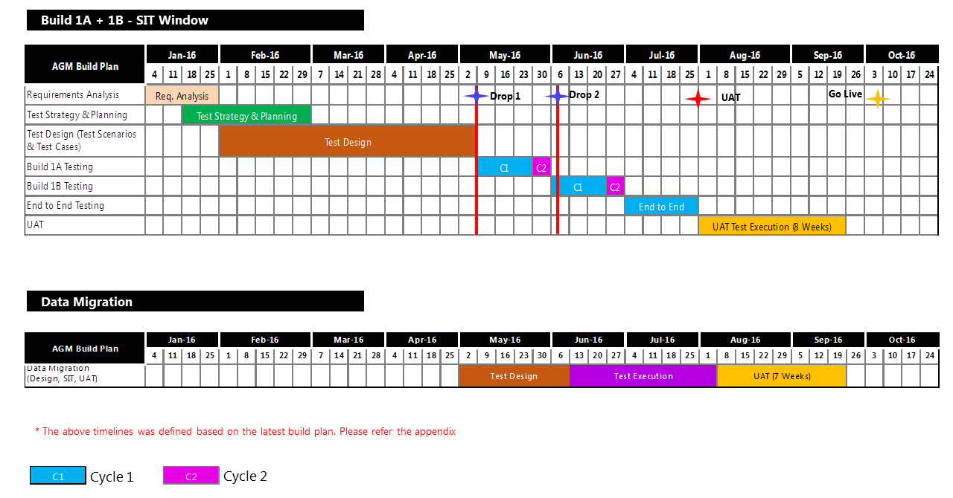

Key Highlights - Build 1A + 1B Test Execution:
- The high level timelines are given based on Work View CGM Build Plan and will change based on the build plan.
- Test Design will be completed by 06th May 2016; Test Execution will commence from 10th May 2016.
- 2 Cycles in each Code Drop; 100% - 1st Cycle and 40% in 2nd Cycle including Defect Retesting. The testing in Cycle 2 with 40% of test cases being executed with an assumption of 30% failure rate in Cycle 1 & 10% regression cases.
- 1 Cycle of End to End Testing is planned for CGM business functionalities after the completion of 1A + 1B build.
- Data Migration Testing - Cycle 1 & Cycle 2 testing will be performed on Migration Test Environment with Work View by comparing with source system.

Quality Gates

- Need to achieve the below mentioned test execution pass % in order to start with next test execution cycles,

Test Cases Execution: Pass %
Build Plan | Cycle 1 | Cycle 2
Build 1A - Test Execution | 65% | 80%
Build 1B - Test Execution | 65% | 85%
End to End - Test Execution | 85% | 90%

Signoff Criteria from SIT to UAT:
- 0 P1 & P2 Defects
- Successful Smoke Test in UAT with all Integrated components
- End to End Pass % > 90

Test Tools

The following table elaborates the different tools that would be used in the course of the Work View Programme at different stages of the project life cycle.

Test Tools | Test Stage | Activities Performed
Microsoft Office Excel 2010 | Test Design | - Preparation of Test Scenarios / Test Cases / Test Conditions  - Preparation of Test Data
HP - ALM | Test Management | - Test Requirements Creation  - Test Design  - Requirements Traceability Maintenance  - Test Execution  - Defect Management
IBM Data Studio 4.1.0 | Database / MI Testing | - Data Validations  - Reports Testing
Notepad ++ | Database / MI Testing | - SQL Query Writing

Defect Management

The main intention of Defect Management is to define and implement processes to manage logging and resolution of defects found during any phase of Software Development Life cycle or Software Testing Life Cycle. A well matured defect management process helps capture proper metrics which are key indicators for assessing test progress and quality. It also helps in efficient tracking and faster resolution of defects.

Defect Life Cycle

Defect management will be done by tracking all the defects in the HP ALM. The defect management process will include daily Defect Triage meetings between all stakeholders to perform impact analysis, discuss and categorize the defects.

Status | Description
New | State used when a new defect is first created. Defect has not yet been reviewed by the Business Analyst/Development team
Investigation | Validation of a new Issue, or a reopened issue. Business Analyst needs to review the defect and identifies the category of the defect. Coding Issues will be assigned to the Developer and Config. Issues will be sorted out by BA.
Fixed | The defect has been fixed, but needs to be verified as fixed through additional testing. Once the fixed is verified, the defect will be moved to SIT environment and the status will be changed to Ready for System Test
Ready for System Test | The defect has been fixed by the Development team and is ready to test by System Tester(s).
Closed | The Cognizant QA team has reviewed the item and can no longer duplicate it. This is the final status for a defect.
Failed Re-test | The defect recurs after the defect has been fixed and is failing while retesting in testing environment
Not a fault | The defect that has been raised is not a fault in the System and is considered as a Tester error
Deferred | Development has not yet scheduled a release time frame. Defect will not be fixed in the foreseeable future. Defect will remain open, because it needs to be addressed sometime in the life of the product. Deferring of a defect has to be agreed by Cognizant QA, Cognizant & Vega Development teams, BA and UAT Team
Re-opened | The defect has been successfully resolved but recurs again after sometime
Awaiting requirement update | The defect does not require any fix but requires a requirement update. After the requirements are updated, Cognizant QA team to verify the application works as per the updated requirement and will close the defect
To be discussed | The defect which needs discussion with other teams (Cognizant QA team, Development team) is marked as “To be discussed”. After discussion in defect triage and arriving at a consensus, the defect will be moved to investigation

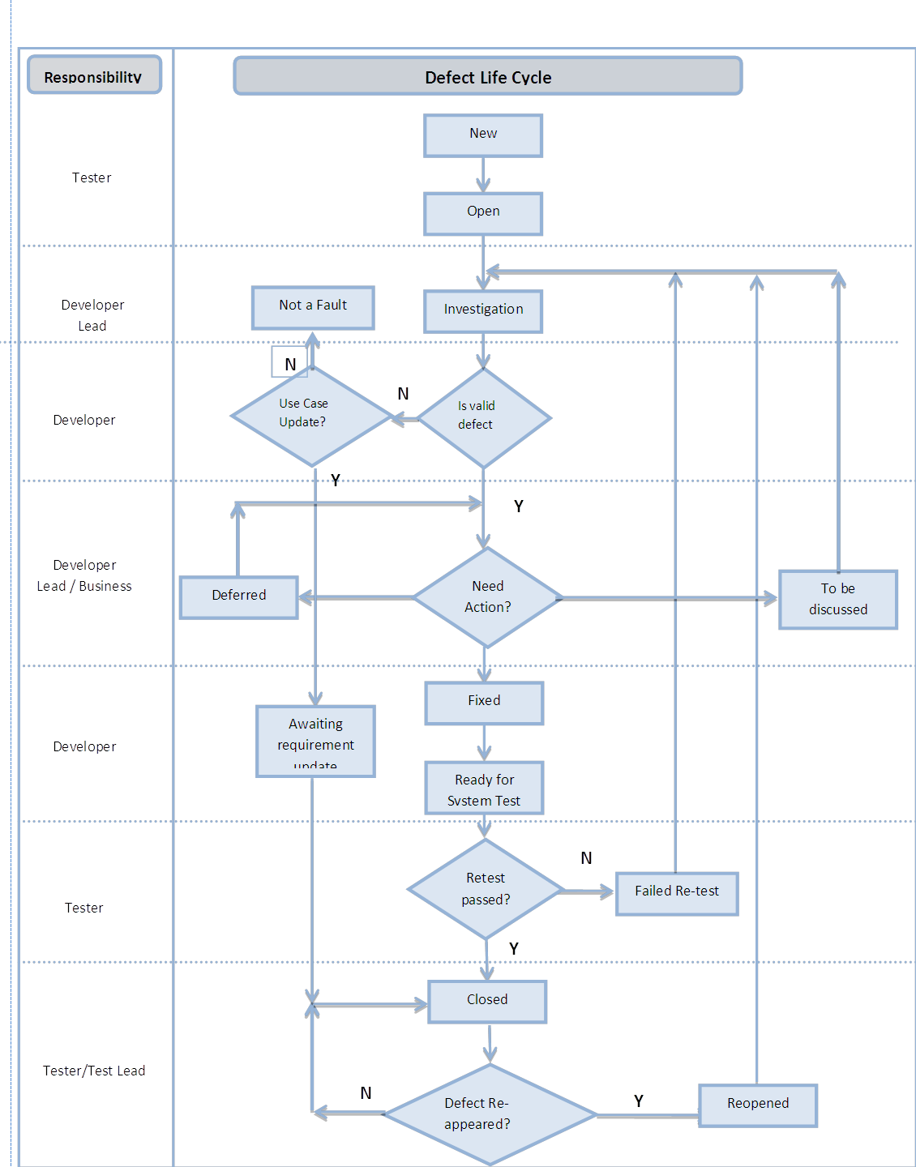

Defect Triage

The main objective of the defect triage meeting is to keep track of the progress on action of defects. It also serves as a forum to address critical and blocking defects that need immediate attention and defects that need input from business, testing or any other involved teams. As part of the Defect Triage Meeting, a defect is prioritized based on importance and criticality of the business functionality being tested.

Defect Triage meetings will be owned by QA Team and it should include the representations from each team including Development Team and Business Analyst

Defect Classifications

Each defect will be classified by Business Severity (impact on the Business if it is not fixed before implementation) and Fix Priority (impact on Testing). The Fix Priority status will be a driver for defect fixes. The Business Severity and Fix Priority levels are as those selectable in HP ALM.

Defect Business Severity

Severity | Description (Business priority regard resolution) | SLAs
1 - Critical | The problem causes complete loss of service. Testing cannot reasonably continue, the operation is mission critical to the business and the situation is an emergency. A Severity 1 problem has one or more of the following characteristics:  - Data corrupted due to which application flow is getting disrupted  - A critical functionality is not available.  - System hangs indefinitely, causing unacceptable or indefinite delays for resources or response.  - System crashes and crashes repeatedly after restart attempts. | Dev Team
2 - High | The problem causes a severe loss of service or functionality failure. No acceptable workaround is available; however, operation can continue in a restricted fashion. | Dev Team
3 - Medium | The problem causes minor loss of service. The impact is an inconvenience, which may require a workaround to restore functionality. | Dev Team
4 - Low | The problem causes no loss of service. The result is a minor error, incorrect behavior, or a documentation error that does not impede the operation of a system. | Dev Team

Defect Fix Priority

Severity | Description | SLAs
1 - Critical | Severe impact on the testing plan such that testing cannot continue until a fix is made available. | Dev Team
2 - High | Significant impact on the testing plan with a large number of test cases affected which awaits a fix in order to continue. | Dev Team
3 - Medium | Moderate impact on the testing plan with only one test case affected which awaits a fix in order to continue. | Dev Team
4 - Low | Little / No impact on the testing plan and testing can continue on the test case affected without a fix. | Dev Team

Test Data

Test Data preparation approach would vary based on the type of testing involved. Test data will mostly be generated through the entry of test scripts into the systems based on the specific test case requirements by QA Team. The range of test data and conditions will need to adequately ensure that each system function is working correctly to the specification. QA Team to ensure test data reflect the realistic range of business conditions and should, when feasible, test each possible condition.

- Prepare test data for the Policy files from Subscribe system by SIT team
- Replication of production data from the Webcon sources Interfaces
- Test Data (like Invoice copies, mails & fax copies) for Ingestion testing should be provided. It can be reused from ASPAC & NA test data dump after initial analysis
- Production dump of interfacing system is required for test data preparation

Test Metrics

Testing Metrics provide pre-defined data upon which progress can be monitored, decisions made and actions taken. Actual metrics are gathered during the test phases, and are used to assess actual progress against planned progress rates.

The following set of metrics will be used to measure progress during different testing phases, the data required to generate metrics below will be sourced from HP ALM primarily.

Test Phase | Metrics Name | Description | Measurement
Test Design | Test Design Coverage | Measures functional coverage of the test cases to the requirements | Quality
Test Execution | Test Effectiveness | To determine testing effectiveness based on the percentage of defects found prior to UAT | Quality
Test Execution | Defect Leakage % (Attributed to Root cause analysis) | Any defect leaked to the next stage indicates that the test / review mechanism for that stage / work product is not adequate. A high leakage rate indicates that the process of review / testing carried out needs to be looked upon. | Quality
Test Execution | Error Discovery Rate | Test cases executed/ Total defects found % | Quality
Test Execution | Test Case Pass % | % Test Case Executed / Passed | Quality
Test Execution | Application Defect Density | The ratio of defects to test cases or the ratio of defects to effort. | Defect
Test Execution | Quality of Fixes | To determine how well development team fixed the defects logged by testing team. | Quality
Test Execution | Defect Aging | Categorizes & represents the open defects by duration for which they been open so far. | Defect
Test Management | % Schedule Variation | This is an indicator to show the capability to meet milestone | On Time Delivery
Test Management | % Effort Variation | This metrics calculates the % of effort deviation from the planned effort. The objective is to reduce the deviation from the estimated effort | On Time Delivery

Test Environments

Below is the different type of environments used for Testing:

Types of Testing | Environment | Region | Owner
Functional Testing (SIT, End to End, Regression) | SIT Environment | CGM | Environment Team
UAT | UAT Environment | CGM | Environment Team

SIT, Performance, UAT & Migration environments for the following applications are required:

- Work View
- Subscribe
- Stub (for WebCon Gateway Messages)

Test Deliverables

Below is the different type of deliverables from Testing:
Phase | Deliverables | Author | Review | Sign Off | Timelines
Test Initiation / Approach | Unified Test Approach | QA Lead | Cognizant Test Manager | CHUBB Project Manager | End of Test Initiation / Approach Phase
Requirement Analysis & Test Planning | Test Plan | QA Lead | Cognizant Test Manager | CHUBB Project Manager | End of RA & Test Planning Phase
Requirement Analysis & Test Planning | Baseline Estimates | QA Lead | Cognizant Test Manager | CHUBB Project Manager | End of RA & Test Planning Phase
Requirement Analysis & Test Planning | RTM | QA Analysts | Cognizant Test Manager | CHUBB Project Manager | End of RA & Test Planning Phase
Test Design | Test Scenario | QA Analysts | CHUBB BA Team  Cognizant QA Lead | CHUBB BA Team | Refer the detailed plan in the timeline section
Test Design | Test Cases / Test Data | QA Analysts | CHUBB BA Team  Cognizant QA Lead | CHUBB BA Team | Refer the detailed plan in the timeline section
Test Execution | Test Execution Reports | QA Lead | CHUBB BA Team  Cognizant Test Manager | Not Applicable | Weekly
Test Execution | Defect Logs | QA Lead | CHUBB BA Team  Cognizant Test Manager | Not Applicable | Weekly Twice
Test Execution | Business Readiness Dashboard | QA Lead | CHUBB BA Team  Cognizant Test Manager | CHUBB Project Manager | End of Test Execution phase
Test Closure | Executive Test Summary Report | QA Manager | CHUBB Project Manager | CHUBB Project Manager | End of Test Closure Phase
Test Closure | Release Retrospection | QA Lead | CHUBB BA Team  Cognizant Test Manager | CHUBB Project Manager | Weekly
Test Closure | GO-NO GO Recommendations | QA Manager | CHUBB Project Manager | CHUBB Project Manager | End of Test Closure Phase

Test Criteria

Test Entry / Exit Criteria

Test Phase | Entry Criteria | Exit Criteria
Test Design | - Requirements (BRD, SAS) base-lined and signed off by the Business  - Availability of SMEs and BAs for Requirements walkthrough and resolving Queries | - Test Coverage 100% Reviewed and Signed Off  - Test Scenarios Reviewed and Signed off  - Requirement Traceability Completed  - Test Cases Uploaded and available in HP ALM
Smoke Testing | - Successful completion of Unit Testing by the Development team with Pass percentage of 90%  - Successful completion of Build deployment to SIT environment and accessible from VDI.  - Release Notes shared with QA Team  - No critical priority issues / defects outstanding from Integration testing  - Work View should be installed in QA VDI  - Subscribe and WebCon should be integrated with Work View  - Availability of Test Users, Data in Reference DB | - 100% Smoke Test Suite Completion  - Pass Percentage of 90%
System Integration Testing | - Successful completion of Sanity Testing  - All test Cases are reviewed and Signed off  - All test cases is uploaded and available in Test lab for execution  - All Tester have access to HP ALM | - 100% of all severity 1&2 defects should be resolved or agreed to be open by the BA team  - 100% Test execution coverage of all must and should features  - Test Execution has achieved 95% and Pass Rate 85%  - Identified Regression test cases should be executed  - Test Completion Report should be delivered and signed off
End to End Testing | - Successful completion of SIT  - All test Cases are reviewed and Signed off  - All test cases is uploaded and available in Test lab for execution | - 100% of all severity 1&2 defects should be resolved or agreed to be open by the BA team  - 100% Test execution coverage of all must and should features  - Test Execution has achieved overall 90% Pass Rate  - Identified Regression test cases should be executed  - All Critical, High or Medium defects should be fixed and retested.  - Non fixed defects should be deferred for future releases based on the defect prioritization by Business.

Test Suspension / Resumption

Suspension Criteria | Resumption Requirements
Non-availability of the application | Availability of the application
Show stopping defects, which prevent further testing along all path and no further testing can be proceeded | Show stopper is rectified
All the possible test cases have been tested with the failure notified and the fixes for the same have not arrived for re-testing. | Arrival of build with fixed defects
Defect Leakage / Recurrence in subsequent rounds of testing | Proper rectification of defects
Testing Environment is not ready or set up properly | Proper availability of Test environment
Defect discovery rate more than 60% | Rectification of defects which opens up majority of test cases

Test Assumptions / Dependencies

Assumptions:

- Test plans/ Approach will be reviewed and agreed by SME’s , BA’s and EA’s
- BA team will provide the signed off Use cases before the start of Test Design. Any delay will impact overall schedule of the project.
- BA or Program Manager to provide sign-off for test scenarios before the execution to baseline on agreed date as per the project plan
- Timely clarification of requirements ambiguities during test design phase.
- Any further change requested to be handled through the change management process based on the impact
- All builds are delivered with 100% functionality as per schedule.
- QA environment to be available with all required hardware, software and configurations one day before the start of test execution
- QA environment to be available >90% of the time during test execution timeframe
- Unit testing will have successfully completed on all items to be tested in SIT
- Developer support will be available throughout the testing phase
- CHUBB SME’s/BA’s will be available throughout the testing phase.
- Dependent systems Subscribe and WebCon will be integrated before the start of the execution by the Dev Team.
- Test environment mimicking production environment in terms of configuration of apps, availability of apps (for UAT and E2E Testing), data volume (for Performance Testing) and data integrity for integration/ end-to-end testing.

Dependencies:

- Testers will have completed training in advance of the testing start date.
- Should have access for dependent systems/Interfaces.
- Support from CHUBB BA for timely clarification of requirements ambiguities during test design phase & to update Query Tracker in CHUBB SharePoint folder.
- QA deploy should be done on the planned delivery date. Delay in code drops will impact quality of the applications (regression defects).
- Dedicated test environment manager and existence of process to plan and monitor the usage and implement the access related requirements.
- Need to define a process to determine the requirement freeze date (after which we requirement change will go in through CR process and revised estimate would be submitted).
- Support is required from third party providers (IBM- Daeja Viewer) for defect resolution.
- Need developer/IT Ops team support to run batch jobs.
- Any unplanned downtime of the Interfaces should be notified well ahead to QA.
- Roadblock defects (Application and Environmental Issues) to be fixed within 4-7 hours on communication.
- Quality of fix should be >80%.

Risks / Contingencies:

Streams | Risks | Impact | Mitigation Plan | Status
Reporting | Unavailability of requirements for MI Reporting | High | Work with the program team to identify the requirements for MI Reporting | Closed
Integration | Support of the Interface team – Subscribe and WebCon till the end of SIT is required | High | Need to work with the program team to identify the POC for the respective Interface team for support until end of SIT | Open
Ingestion | Setting up of hardware devices and provide access for SIT Test Users - Multifunctional Device, Scanner, FAX, Apollo Print | Medium | Need to work with the environment team to get the necessary access prior to SIT | Open

Roles & Responsibilities

The following table defines the roles and responsibilities of the key stake holders in testing.

Role | Responsibilities
CHUBB Project Manager | - Provide support to ensure the testing effort is successful  - Manage and communicate project status and change control  - Coordinate Review and Sign off Test Plan  - Coordinate Review and Sign off Test Cases  - Review and Sign off on Test Summary Report
CHUBB Business Analyst | - Provide KT to the Test Analysts (if required)  - Provide support on resolving clarifications raised by Testing team  - Review and Sign off on high level and detailed test cases
Cognizant Test Manager | - Responsible for overall testing delivery of the project  - Review and approve all major testing deliverables  - Work with CHUBB Project Manager to evaluate and implement changes to the project testing scope, testing approach and/or testing schedule  - Create / Update / Maintain Project Plan  - Participate in management reviews and teleconferences  - Provide identified issues to CHUBB Project Manager to be encapsulated as lesson learnt post-implementation  - Provide or report on overall status of testing as needed  - Maintain the Test Plan and ensure adherence to it during the entire testing project
Onsite Test Lead | - Status reporting to CHUBB Program Manager  - Establish a central area for logging and tracking issues and defects until resolved or prioritized with a future date (if applicable). To be determined by CHUBB Program Manager  - Communicate status of overall test results to CHUBB Program Manager by the testing phase in progress  - Single point of contact for all project related queries and ensure clarifications are provided on a timely basis  - Prepare milestone document and detailed project plan  - Participate in the requirements design review  - Analyze and report requirements coverage  - Coordinate test case design  - Coordinate test data preparation/generation  - Report defects according to the defined process  - Coordinate the overall project testing effort  - Manage the defect tracking / reporting process  - Coordinate onsite and offshore testing efforts  - Work allocation and Status reporting
Offshore Testing Team | - Review and validate requirement specification  - Design Test Scenarios  - Design Test Cases and Peer Review  - Prepare Test Data and Peer Review  - Coordinate Test Case Execution  - Report defects according to the defined process  - Manage the defect tracking / reporting process  - Metrics Collection

RACI Matrix

The following RACI (Responsible, Accountable, Consulted, and Informed) matrix captures the role of different stake holders of this project across stages/activities related to Testing.

Phases | Activity | Cognizant |  |  |  | CHUBB
Phases | Activity | Delivery Manager | Test Manager | Test Lead | Test Analyst | Program Manager | Business Analyst
Test Requirement Analysis | Study Functional Specification and Business Requirements Documents | I | A | R | R | I | C
Test Requirement Analysis | Conduct Requirement Ambiguity Clarifications Sessions | I | A | R | C | I | C
Test Design | Prepare Test Conditions | I | A | R | R |  | C
Test Design | Prepare Test Cases / Test Data | I | A | R | R | I | C
Test Design | Identify Smoke Test Cases | I | A | R | R | I | C
Test Design | Review and Sign off Test Conditions / Scenarios | I | I | A | R | I | C,R
Test Execution | Execute Test Cases / Test Scripts | I | A | R | R | I | C
Test Execution | Conduct Defect Triage Meetings | I | A, I | R | C | I | C
Test Execution | Prepare and Publish Test Metrics Report to the project management team | I | A | R | R | I
Test Execution | Support UAT Test Execution (If applicable) | I | A | R | R | I | C
Test Execution | Review UAT Defects (If applicable) | I | I | C | C | I | C
Test Execution | Review Outstanding Defects and Obtain Business Approval | I | A | R |  | I | C
Test Closure and Production Checkout | Prepare / Refine end of Test Summary Report | I | A | R | C | I
Test Closure and Production Checkout | Execute Production Checkout Test Cases / Test Scripts | I | I | A | R | I | C
Test Closure and Production Checkout | Publish Functional Test Summary Report to the project management team | I | A | R | C | I

Reference Documents

CGM R1 Functional Specification v0.12
http://europespace.acegroup.com/sites/AR_AGM_Project/Shared%20Documents/03_Functional_Design/04%20Functional%20Specification/AGM_R1_Functional_Specification_v0.15.docx
CGM R1 Functional Catalogue v0.6
http://europespace.acegroup.com/sites/AR_AGM_Project/Shared%20Documents/03_Functional_Design/03%20Functional%20Requirements/AGM%20Functional%20Catalogue%20v0.6.xlsx
CGM Ingestion Configuration v0.4
http://europespace.acegroup.com/sites/AR_AGM_Project/Shared%20Documents/03_Functional_Design/04%20Functional%20Specification/AGM%20Ingestion%20Configuration%20v0.4.xlsx
Latest UI Customisation v0.9
http://europespace.acegroup.com/sites/AR_AGM_Project/Shared%20Documents/03_Functional_Design/04%20Functional%20Specification/AGM%20UI%20Customisation%20v0.9.xlsx
CGM R1 Workflow TDD v1_5
http://europespace.acegroup.com/sites/AR_AGM_Project/Shared%20Documents/06_Technical_Design/Vega%20TDDs/In%20Process-Awaiting%20Sign-off/ACEView%20AGM%20Workflow%20TDD%20v1_5.docx

CGM R1 Business Requirements:
http://europespace.acegroup.com/sites/AR_AGM_Project/SitePages/Home.aspx?RootFolder=%2Fsites%2FAR%5FAGM%5FProject%2FShared%20Documents%2F02%5FBusiness%5FRequirements%2F03%20Business%20Requirements&FolderCTID=0x01200052411B3848C8C345AB3BED74E8001E98&View={C02F41EC-883B-4EFE-A079-60CF5F7AE0FD}&InitialTabId=Ribbon%2EDocument&VisibilityContext=WSSTabPersistence
BR2 Global Requirements
https://officespACE.ACE-ina.com/s/Apollo2Symposium/General/Apollo%20Refresh%20Program/04%20Release%201/02%20Wave%201%20and%202%20Business%20Requirements/01%20Global%20Requirements/BR2_Global%20Requirements%20Catalogue_v0%2041.xlsx
Data and Application InterfACEs Requirements
http://europespace.acegroup.com/sites/AR_AGM_Project/SitePages/Home.aspx?RootFolder=%2Fsites%2FAR%5FAGM%5FProject%2FShared%20Documents%2F11%5FInterface%5FAnalysis&FolderCTID=0x01200052411B3848C8C345AB3BED74E8001E98&View={C02F41EC-883B-4EFE-A079-60CF5F7AE0FD}
Core Use Cases
https://officespACE.ACE-ina.com/s/Apollo2Symposium/General/Forms/AllItems.aspx?RootFolder=%2Fs%2FApollo2Symposium%2FGeneral%2FApollo%20Refresh%20Program%2F04%20Release%201%2F03%20Wave%201%20and%202%20Functional%20Design%2F06%20Core%20Functional%20Design%2F02%20Core%20Use%20Cases%2F03%20Baselined%20Use%20Cases&FolderCTID=0x012000B7F9EC70C9752B4DA37DF18AA4F04B81&View=%7B63698F83%2DC9C8%2D44F4%2DA5E9%2D560C9C24594E%7D&InitialTabId=Ribbon%2ERead&VisibilityContext=WSSTabPersistence#InplviewHash63698f83-c9c8-44f4-a5e9-560c9c24594e=FolderCTID%3D0x012000B7F9EC70C9752B4DA37DF18AA4F04B81-InitialTabId%3DRibbon%252ERead-VisibilityContext%3DWSSTabPersistence-SortField%3DModified-SortDir%3DDesc

